CS 255 System Design Document Template

This template lays out all the different sections that you need to complete for Project Two. Each section has guidance to prompt your thinking. You will need to continually reference the interview transcript as you work to make sure that you are addressing your client’s needs. There is no required length for the final document. Instead the goal is to complete each section based on what your client’s needs are. Remove this note when you are finished, and replace all bracketed text with the relevant information.

UML Diagrams

UML Use Case Diagram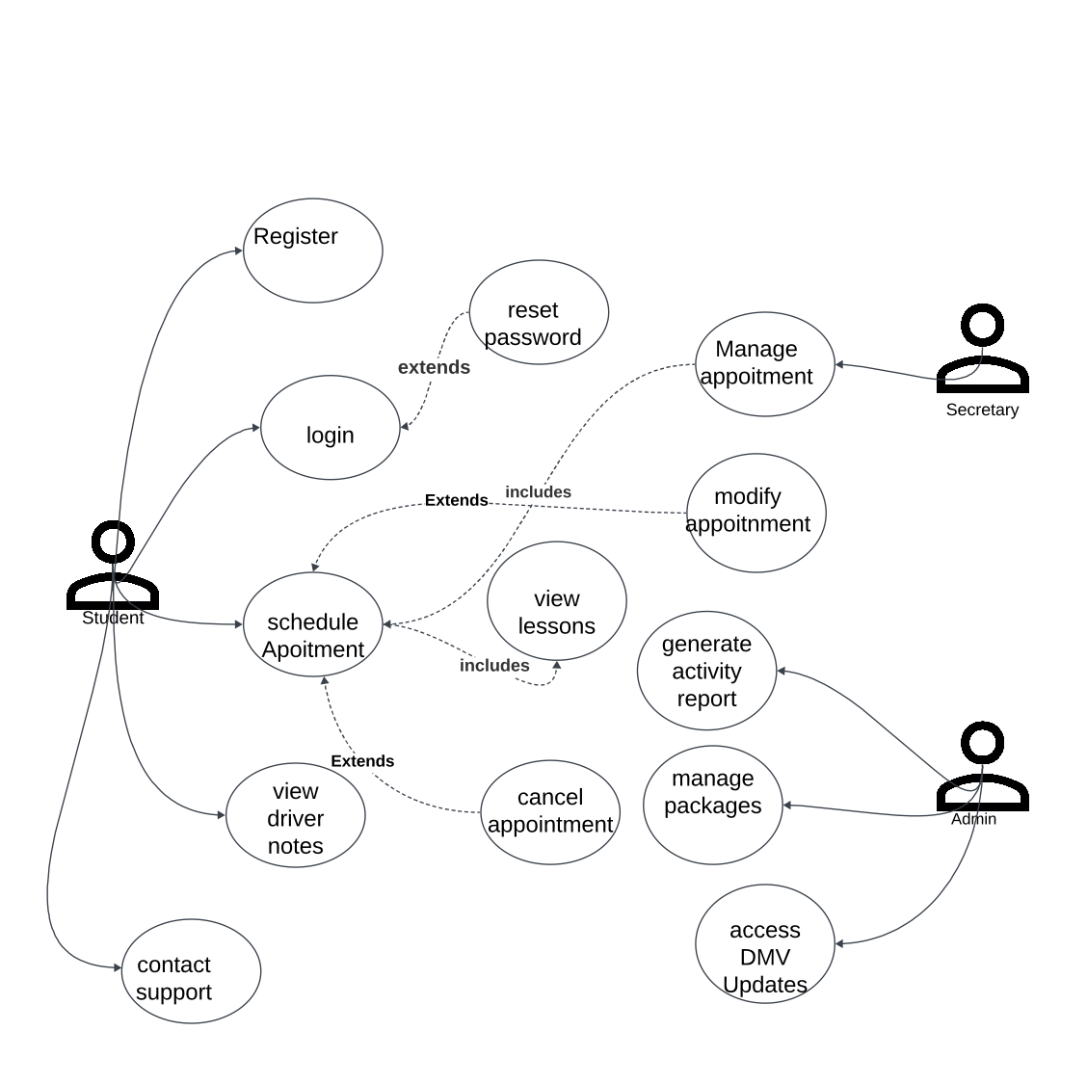

UML Activity Diagrams
[You were asked to choose two use cases and create two activity diagrams, one for each use case. Please insert both of your activity diagrams here. Check to make sure that you included appropriate components and symbols and that your design meets the client’s needs.]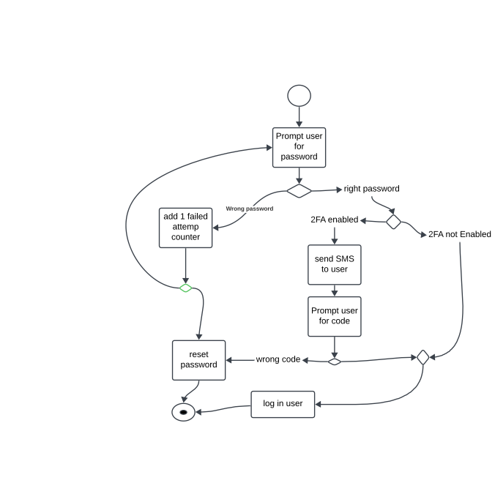

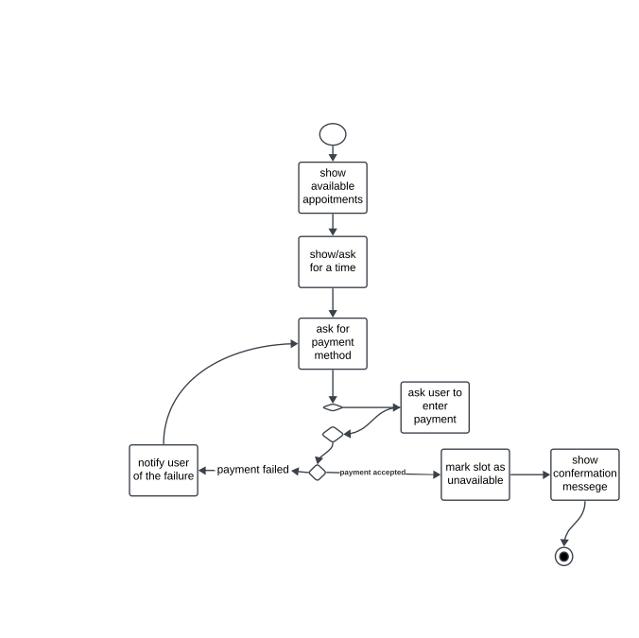

UML Sequence Diagram
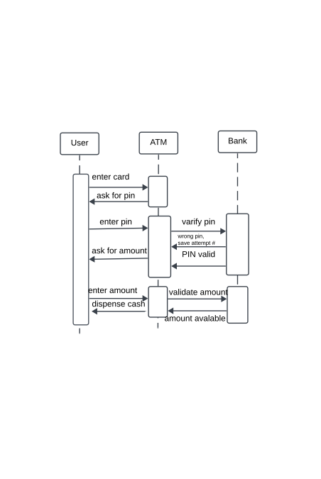

UML Class Diagram
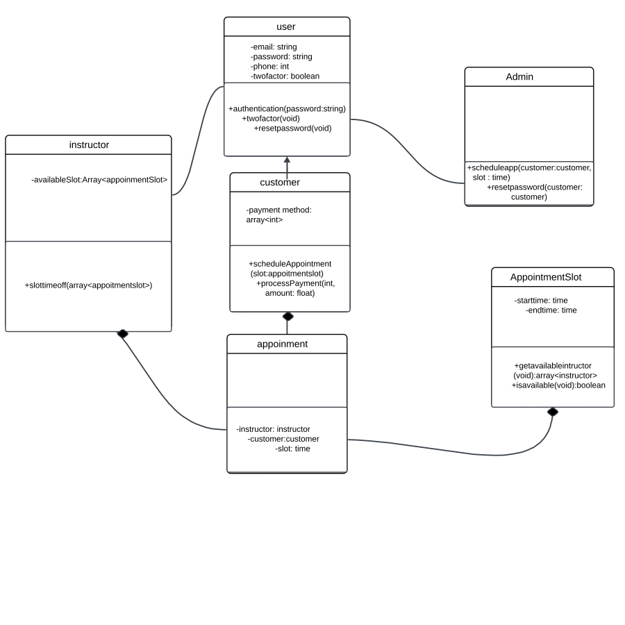

Technical Requirements
• A host server to operate the backend database and web interface, ensuring a stable internet connection at all times.
• Service for processing payments efficiently and securely.
• An office computer with a web browser for accessing the interface.
• Reliable payment gateway integration for handling transactions.

